Adriana Rodriguez

11/26/23

CSD 310 Module 8.2 Assignment

**Assignment: Movies: Update & Deletes**

For this assignment, you will be learning how to update and delete records from a MySQL database.

###### **1. MySQL Instructions**

* MySQL: Update (Using different examples, of course..)
  + UPDATE <table> SET <columns> WHERE <column> = <value>;
* MySQL: Delete
  + DELETE FROM <table> WHERE <column> = <value>;
* MySQL: Insert
  + INSERT INTO <table> (<columns>) VALUES ( <values> );

###### **2. Python Instructions**

* You'll be displaying selected contents of the film table multiple times, so create a python function that you can call with both a cursor and an output.
* The function should take two arguments; a cursor and a title.
* The body of the function should have a cursor that executes a select statement that selects film name as Name, film director as Director, genre name as Genre, and studio name as Studio.
* In order to get the genre name, and not id, you'll need an INNER JOIN. In order to get studio name, and not id, you'll need another INNER JOIN.
  + Example: select film_name as Name, genre_name as Genre, studio_name as 'Studio Name' from film INNER JOIN genre ON film.genre_id=genre.genre_id INNER JOIN studio ON film.studio_id=studio.studio_id
  + In Python, if you must use more than one line for the select, there are a few ways to manage it. You'll have a little research to do.
* Next, is the cursor. fetchall() statement
* Format the output label..
* Lastly, iterate over the data set and display results.

###### **3. Instructions**

* Create a new file under the **module_8** directory and name it **movies_update_and_delete.py**.
* Using the example code I provided, connect to the **movies** database.
* Using the example code I have provided, call the ref function to display the selected fields and the associated Label.   
  show_films(cursor, "DISPLAYING FILMS")
* Insert a new record into the **film** table using a film of your choice. Do not use 'Star Wars'. (Easier if you use a studio already in use..)

# insert film record

INSERT INTO film(film_name, film_releaseDate, film_runtime, film_director, studio_id, genre_id)

VALUES('M3GAN', '2022', '132', 'Gerard Johnstone', (SELECT studio_id FROM studio WHERE studio_name = 'Universal Pictures'),(SELECT genre_id FROM genre WHERE genre_name = 'Horror') );

* Using the example code I have provided, call the ref function to display the selected fields and the associated Label.
* Using the example code I have provided, update the film Alien to being a Horror film.

# update Alien film genre

UPDATE film, genre

SET genre_name = 'Horror'

WHERE film_name = 'Aliens';

* Using the example code I have provided, call the ref function to display the selected fields and the associated Label.
* Using the example code I have provided, delete the movie Gladiator.

# delete Gladiator movie

DELETE FROM film

WHERE film_name = 'Gladiator';

* Using the example code I have provided, call the ref function to display the selected fields and the associated Label.
* Take a screen shot of the results.. or copy the output, and paste into a Word document.

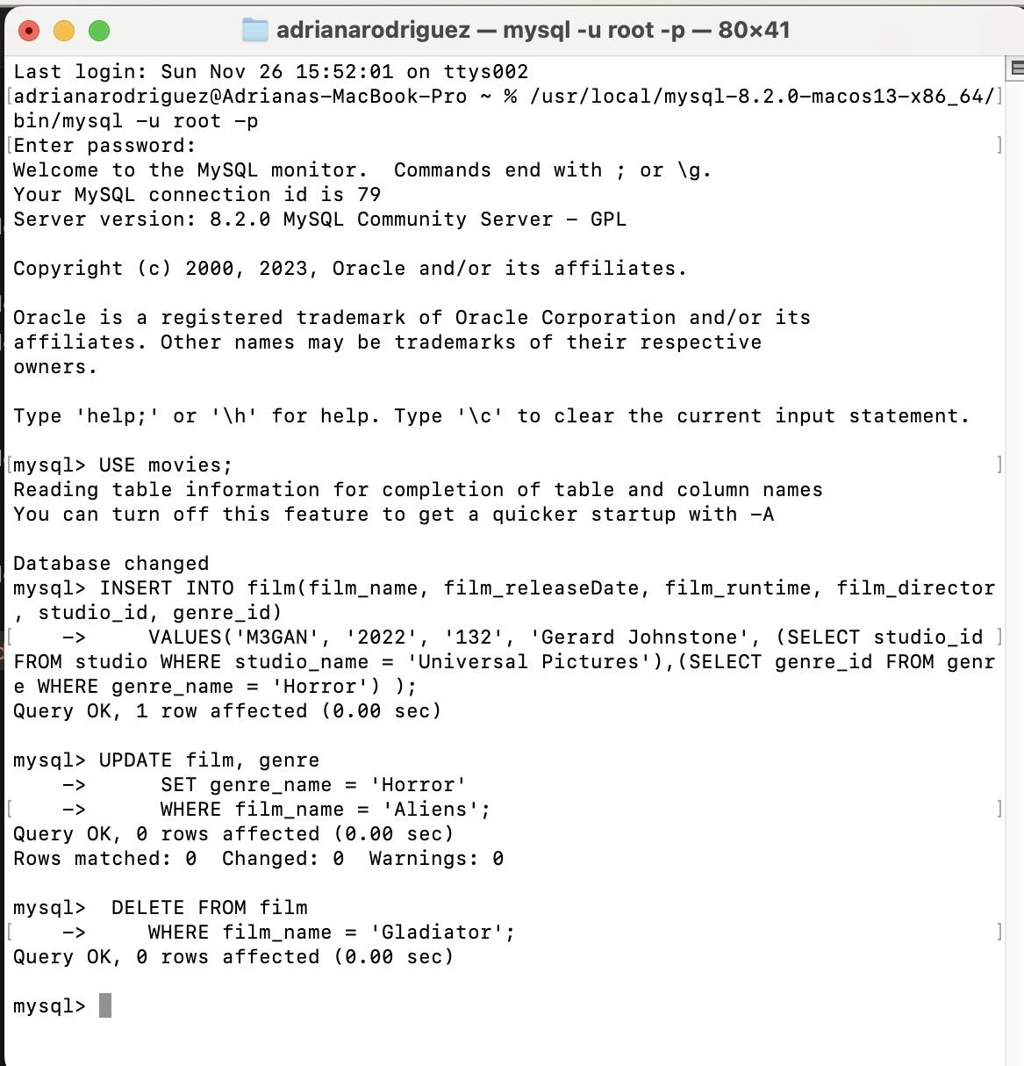

* Make sure your output matches the expected output (this is gradable.)
  + Expected Output

###### **3. GitHub**

* Stage, commit, and push your work to GitHub.

###### **4. Deliverable**

* Link to your GitHub repository.
* movies_update_and_delete.py
* Either a Word doc with your screenshots, or the copied output.